1. LIST ENAME, JOB, ANNUAL SAL, DEPTNO, DNAME WHO EARN 30000 PER YEAR AND WHO ARE NOT
CLERKS??
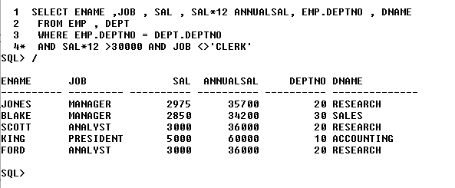
2. LIST OUT THE ALL EMPLOYEES BY NAME AND EMPLOYEE NUMBER ALONG WITH THEIR
MANAGER'S NAME AND EMPLOYEE NUMBER??
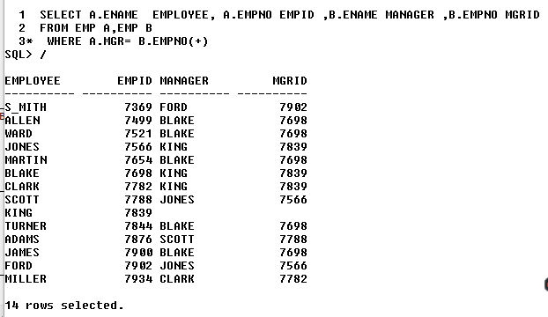
DISPLAY ENAME ,DNAME EVEN IF THERE NO EMPLOYEE WORKING IN A Particular department ??
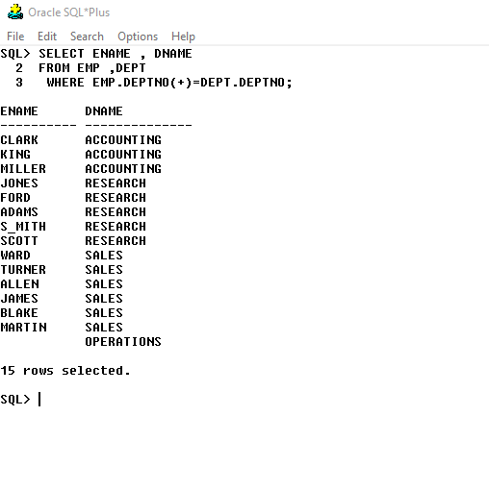
- DISPLAY THE DEPARTMENT NAME ALONG WITH TOTAL SALARY IN EACH DEPARTMENT??
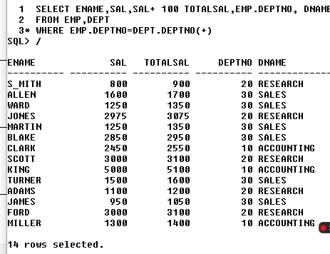
- DISPLAY EMPLOYEE NAME AND DEPARTMENT NAME FOR EACH EMPLOYEE??

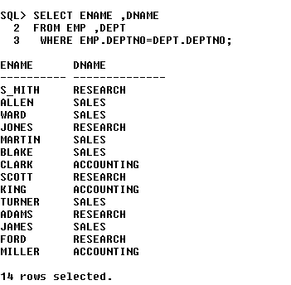
- D?ISPLAY LOCATION NAME OF THE EMPLOYEE WHO EARN COMMISSION.?

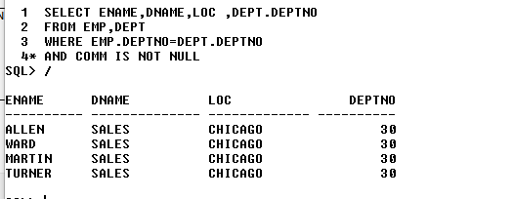

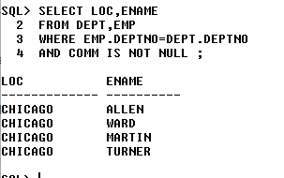

DISPLAY DEPT NAME OF THE EMPLOYEE WHO EARN MIN SALARY AND HAVE NO REPORTING
MANAGER.??

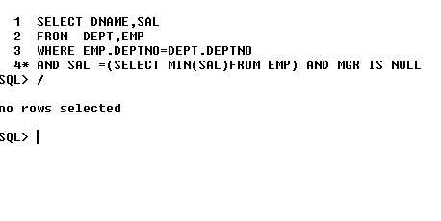
DISPLAY DEPT NAME,LOC OF ALL THE EMPLOYEES WHO ARE REPORTING TO SMITH.??

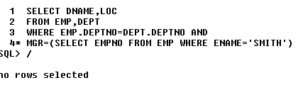
- LIST ALL THE DEPT NAME AND LOCATION OF ALL THE SALESMAN MANAGER'S MANAGER.??

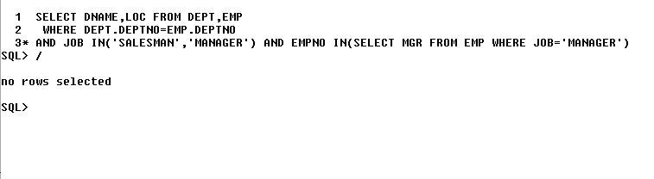
- LIST EMPLOYEES WHO ARE WORKING IN RESEARCH DEPT AND THEY ARE MANAGER.??
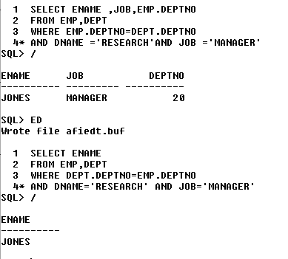

DISPLAY THE NUMBER OF EMPLOYEES WHO ARE GETTING SALARY LESS THAN THE BLAKE'S
MANAGER.??

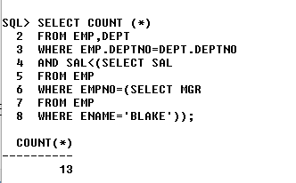
12. LIST THE EMPLOYEE DEPTNAME AND LOCATION OF ALL THE EMPLOYEES WHO ARE
ANALYST,REPORTING TO BLAKE.??

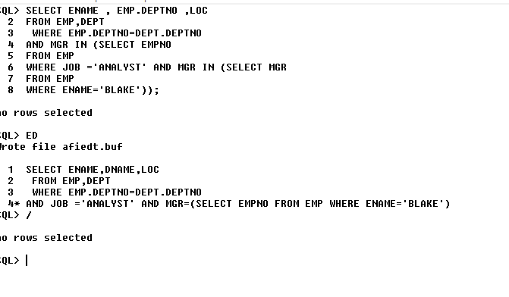
- DISPLAY THE EMPLOYEE NAMES,HIREDATE,COMM OF FORD'S MANAGER??
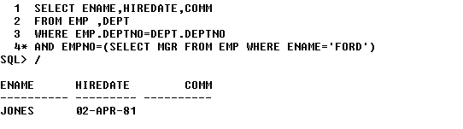

14. DISPLAY ENAME, DNAME OF ALL THE EMPLOYEES WHOSE SALARY LESS THAN AVG SAL OF DEPT
30??
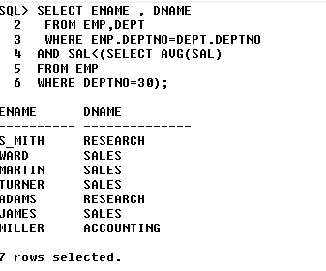
15.DISPLAY ENAME DNAME AND LOC OF ALL THE EMPLOYEES WHO ARE WORKING FOR JONES??

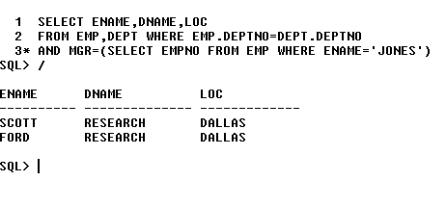
- DISPLAY ENAME DNAME OF ALL THE EMPLOYEES WHOSE NAME STARTS WITH S??

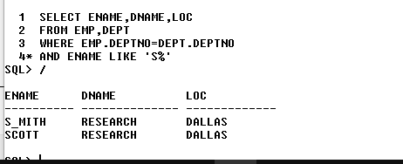

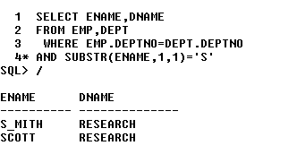

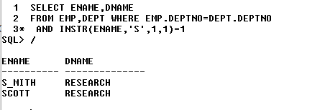

- LIST THE DNAME WHO ARE NOT HAVING ANY EMPLOYEE IN IT??

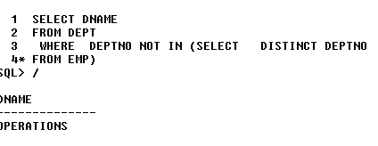
- DISPLAY EMPLOYEE WHO ARE GETTING SAME COMMISSION??


19. DISPLAY ALL THE DEPT NAMES IRRESPECTIVE OF ANY EMPLOYEE WORKING IN IT OR NOT. IF AN
EMPLOYEE IS WORKING DISPLAY HIS NAME.??
20. WRITE A QUERY TO DISPLAY EMPLOYEE NAME, JOB, DNAME, LOCATION OF ALL EMPLOYEES WHO
ARE WORKING AS ACTUAL MANAGERS AND WORKS AT CHICAGO.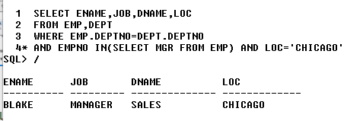??

LIST THE DEPARTMENT NAMES IN WHICH THE EMPLOYEES ARE HIRED BETWEEN 1ST OF JAN 1981
AND 31ST DEC 1982 WITH SALARY MORE THAN 1800.??

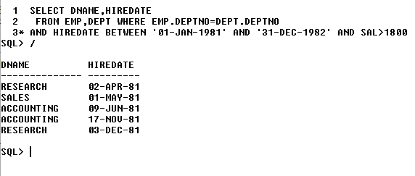
- DISPLAY 2ND LEAST SALARY FROM EMPLOYEE TABLE.??

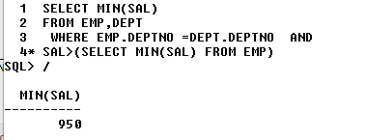
23. LIST THE EMPLOYEES WHOSE ANNUAL SALARY IS GREATER THAN 1500 AND WHO ARE JOINED
BEFORE 1982 ONLY.??

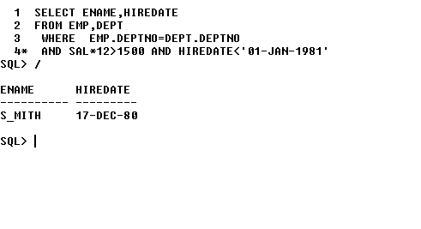
DISPLAY DNAME, LOC, DEPTNO OF EMPLOYEES WHO HAS SAME REPORTING MANAGER?

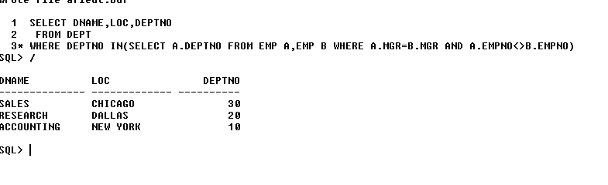
- DISPLAY EMPLOYEE NAME ALONG WITH THEIR MANAGER NAME.?

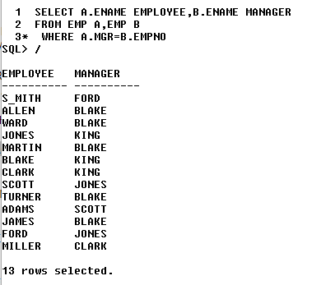
26. DISPLAY EMPLOYEE NAME AND HIS DEPT NAME FOR THE EMPLOYEES WHOSE NAME STARTS WITH
‘S’.?
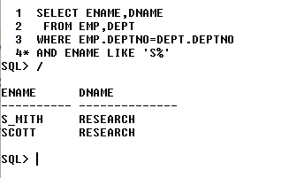

- DISPLAY EMPLOYEES WHO ARE GETTING SAME SALARY.?

